Interactive tutorials
—for web agent framework 1.1
Written by LiXizhi
Email: lxz1982@hotmail.com
2003-10-8

This Tutorial will guide you through the basic steps to explore web agent network as well as how to build up your own agent on the web. It will take you approximately 30 mins to complete.

Content:
Quick introduction:
Tutorial 1: Join web agent framework (WAF)
Tutorial 2: Start from the first agent node
Tutorial 3: Saving your works and working off-line
Tutorial 4: Drag and drop in two map views
Tutorial 5: Edit your own agent
Tutorial 6: Tips for client application
Tutorial appendix 1: deployment of WAF server

Quick introduction:
Web agent framework is simulated human-relationships on the internet. You can easily establish your presence on the network and exposing information in your new private network (that includes all your legacy info) to the whole world. The most fascinating feature is that you can form relationships with other users just like in the real world. With our free client software, you can graphically browse through the virtual human-relationships on the internet. This means that you can find people and their presence on the web from the people you already know. Here is a portion view of an explored human-relationship map on a user’s computer.
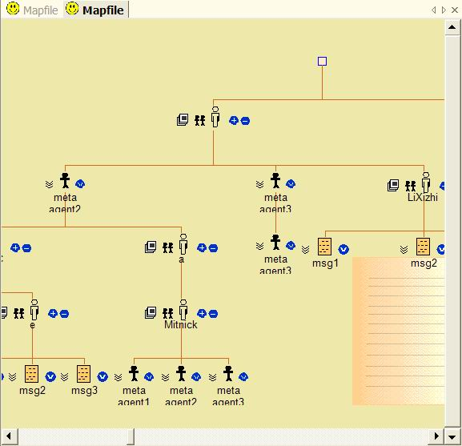

Tutorial 1: Join web agent framework (WAF)
To join the community, you need either to find an available web server on the internet or run your own server in your PC (the availability of your presence created in PC depends on your PC’s availability on the internet or intranet). For tutorials of running personal or community WAF server, please read deployment of WAF server in the appendix. Now let’s assume that you have found a WAF server in http://10.111.11.123/agent/
All you have to do is to open the web address in your internet explorer and follow the instructions. Normally you will see a page like this:
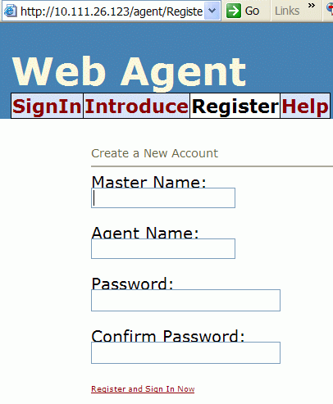
After registering on any WAF web server, you are given a master account and a string like this one http://10.111.11.123/agent/agent.asmx?user=Mike[12], this is the entry point or address for your new presence on the network. Notice that you also need to specify an agent name when registering. More precisely, the address you get is this agent’s address. Since we actually we use an intelligent (reactive) agent to represent your presence on the network. Agent is the atomic element in web agent framework, it looks over legacy info for its master, manage the incoming and outing messages, maintain the relationships with other agents on any available network (internet or intranet), and secure the master’s critical files. One master account could create multiple agents to work for him on the web( possibly one as a teacher having students in a school, another as a member in a club).

To continue to the next tutorial, you should either have one of your own agent on the web or some valid agent address your friend have told you. (Note: In offline mode, you can access to some internal agents created for demonstration in any of our software release. But it’s not explained in this tutorial. Please refer to the Manual Document that come with your release)

Tutorial 2: Start from the first agent node
Install and run the clientagent.exe. See below:
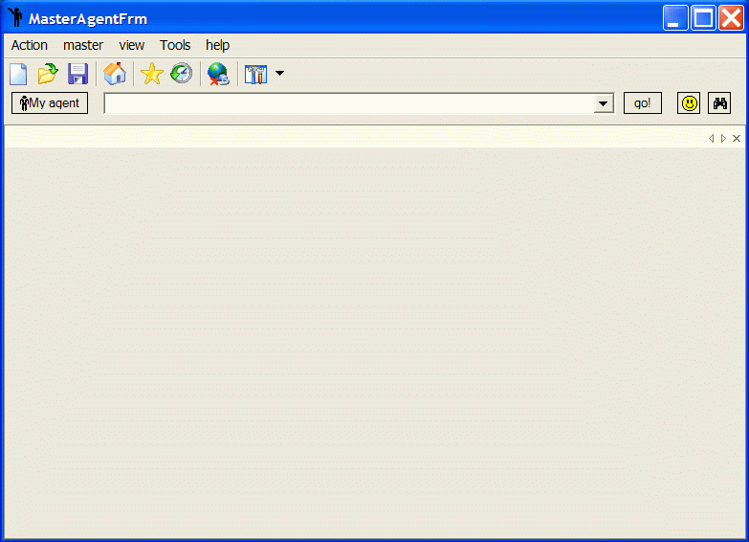
It is the client application for the web agent framework. You can use it to locate people you know of, find their friends, and friend’s friends in an unprecedented manner.

Let’s suppose you already got an valid agent address like this one:
http://10.111.11.123/agent/agent.asmx?user=Demo[31], type it into the edit box on the top and press go. (If you don’t know any valid address, please go to tutorial 1 or ask the one who introduced you to this software. Alternatively you may wants to try one of the demo user in the local database. See tutorial using offline mode.)
If the address you typed is correct and your network connection is all right, you will see an agent icon displayed in the view. See below.
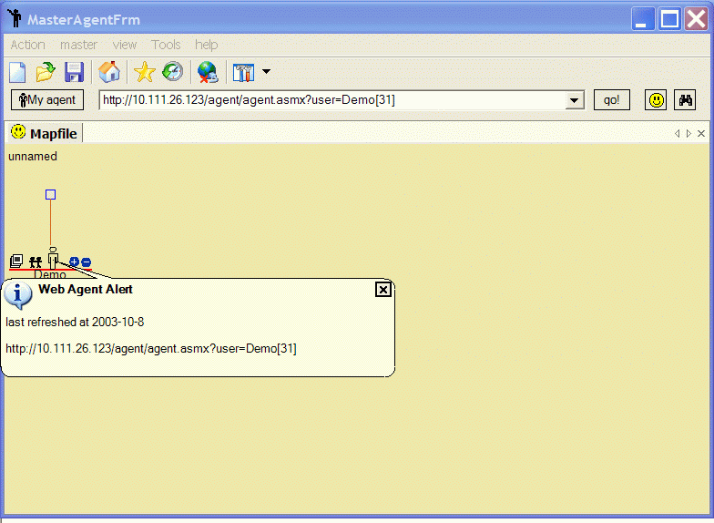
Now that you have downloaded a reference of this agent from the web to your local computer. You can do many things with this reference. Let’s try some. There are two icons on the left of the node and two on the right. Their functions are displayed on the following figure:
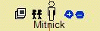
public message | fetch friend | [Name of the agent] |zoom out | zoom in
The most important mini-icon is the second one from the left. You can see what other agents are related to this agent by clicking this mini-icon (fetch friend). You can also download public messages that this agent offer by clicking public message mini-icon.
(note: in order to trigger mini-icon function, you need first select (left click on the node) the agent in the map view. Selected icon are underlined in red. )
For more information on the node, you can right click on the node and select from the popup menu.
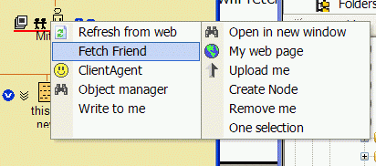
Frequently used menu items are:
Refresh from web: Refresh the node from the web. (Friends and messages are also refreshed)
Client Agent: Open the client agent to access functions you can perform on this node
Object manager: Show the detailed information on this node. It’s like the property view in most application.
After a while, your map view may be something like this.
Now that you have grasped the basics of exploring the web agent framework. In the next tutorial you will learn how to save your work to a map file.

Tutorial 3: Saving your works and working off-line
Each time you download an agent or message from the web, its reference is stored in a local database. You can load them into your mapview without connecting to the network.
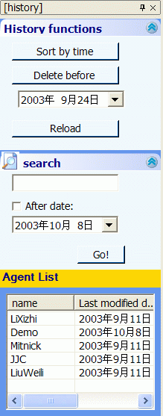
In the toolbar, you can open the history box like the one show above. In the agent list section, there are agents you have downloaded. Double click or right click on the name to add this agent to the current view.
Another way to preserve your work is to save the map view into an XML file. Note that those XML files only save the graphical presentation of each node, the content of the node are stored in a local database just like the one you see in the history box.
Whenever you download an agent that is already in the local database, you will be asked to either use the copy in the local database or refresh it from the web. To cancel this option, you can check the off-line button in the toolbar, so that everything will be loaded from the local database as the default behavior.
When you are exploring the web agent framework, you see the relationships defined by each individual agent on the web. However, after you have them downloaded into your computer, you can redefine their relationships in the map view and save them into map file. See the next tutorial for customizing the map view.

Tutorial 4: Drag and drop in two map views
You can drag one node from one place to another place (possibly to another mapview) in the client application. This function is extremely useful when you need to create your own human-relationships on your computer for people you have downloaded, since the original relationships are defined by each individual on the web. You can save them into a single map file. Remember that content about each node in the map file are stored in the local database, so that they stay consistent and up-to-date with your most recent copy. (In other words, you may have the same agent in multiple map files on your computer, but they are stored, updated and identified as one entity in your computer.)

Suppose you are a student in Zhejiang university. Let’s now try making a piece of synthesized campus newspaper in your mapview using drag and drop functionality. It shall contains a piece of news in your college, separate homework information from the teacher in your school, and a list of newly uploaded movies in your campus FTP. After creating this map file, you can have your client application to collect those information from each of its agent provider on the web when you load this map file next time (possibly every morning).

For simplicity, let’s imagine there are so many people in the agent framework in your campus network that each of your teacher has an agent, your college provides an agent that offers college news and one schoolmate provide information about new movies on his agent.
Now all you have to do is to drag those news from their provider agent into one map view and save to disk. There is already an sample file called MySchools.XML in the [app]\default\ directory when this software is installed. You can use it for practice (A shortcut to this file is through clicking the Home button from the toolbar, you can then find the file in the tree view of the manager window which is explained in next tutorial). Now open MySchool.XML in any way you like.
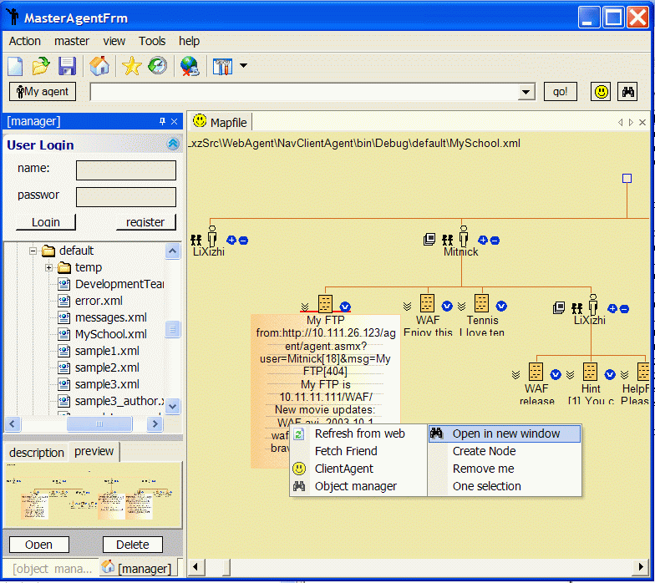
(Tips: When the map view is too big to be displayed in the window, you can scroll using your mouse. To do so, click and hold your mouse in a blank area of the map and move. The view will be scrolled as you drag and move your mouse)
Although you can open an blank map file, click on the tab and choose new vertical tab group to have two view displayed at the same time, the quickest way of doing it is to right click on a node, say My FTP, and choose Open in new window(like shown on the above figure). You will notice that a reference to the My FTP message has been opened to a new window next to the old one. Now you can drag other message nodes to the new window. Finally you will have your synthesized newspaper page finished. Right click on the new map and choose save. See the following graph.
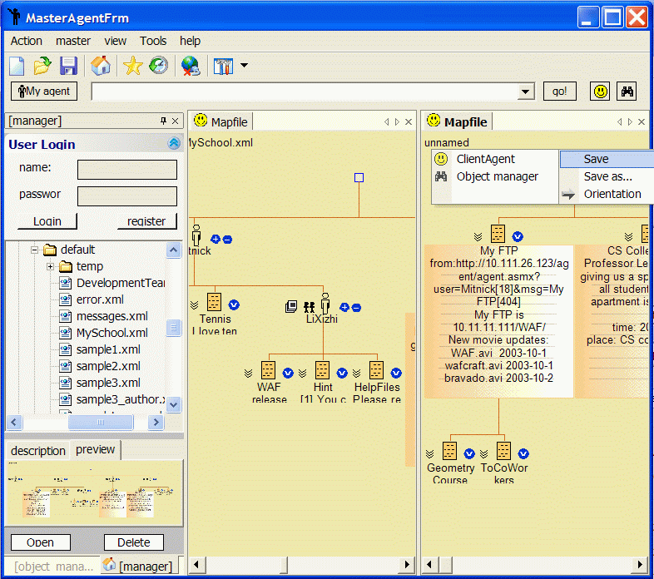
So far, you have learned all the basics of exploring the web agent framework and making custimized backups. In the next tutorial, you will learn how to manage your own agent, such as adding new friend, new messages and web pages and more.

Tutorial 5: Edit your own agent
To manage your own agent, you need to have your access permission. Since most of the download request you made to web agents in previous tutorials do not need specific permission by default. However, actions such as adding friends and messages need master permissions.
To go on with this tutorial you need to register an account on a valid WAF server. If you have not done so, please go back to tutorial 1 to learn how.
Before you can update your own agent on the web. You need to register and login on your client application using the same account you registered on the WAF server. Click Home button in the toolbar, You will see the login box, type the master name and password and press register otherwise login if you have done so before. The client application create a folder using the master’s login name in the application’s installation directory. When you login, the folder view will be navigated to this directory. Conventionally, you may wants to save all your map files in this directory. The client application maintains a separate local database for each registered local user. If no user is logged in, then a user named ”default” is logged in. All sample and tutorial files are stored in the “default” user account.
Note that, even you have logged on, the client application does not validate your account. Validation only occurs when you perform transactions with your own agent on the web server.
When you log on with your master account, you can update your own web agent on the web. To do so. Right click on your agent node in the map view and open its object manager. You can now edit your profiles and click update. If your master account is correct, your agent will be updated to the server. See below:
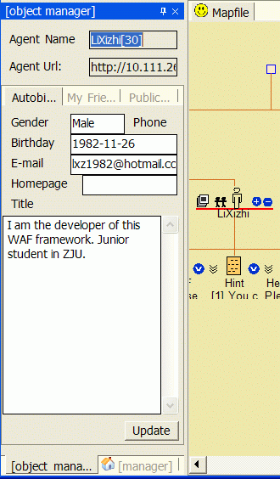
To add messages, click public message tab in the object manager. Press new to add a new message and right click and select delete to remove messages. See below:
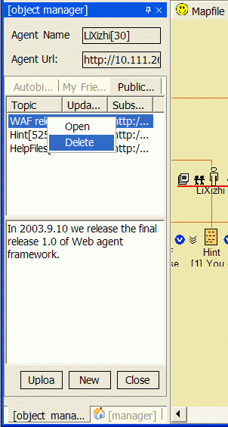
Note: you can only add and delete new message entries in this place. To update an existing message (possibly immediately after creating it), you need to click on the message node which belongs to your agent and display it using object manager. Edit in the text box and click update. See below:
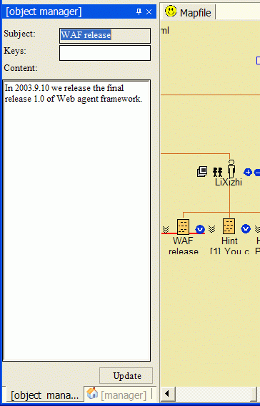
To manage your friend list is the easiest of all. You just drag and drop agent to your agent node in the view and right click on your agent and select upload me. Any child agent nodes under your web agent node will be your new friend list. You can delete an agent node by right click and select remove me. See below
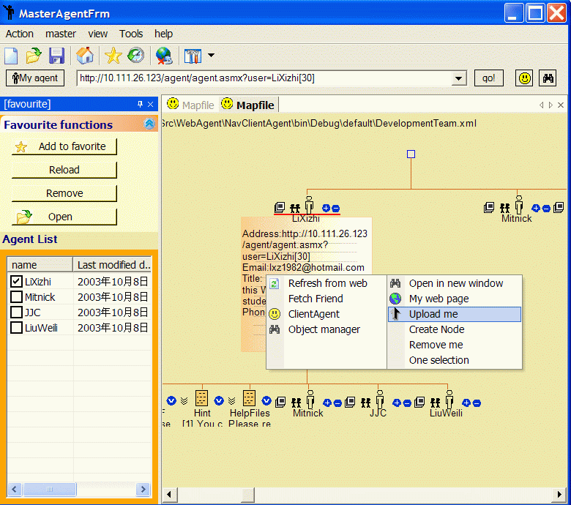

Tutorial 6: Tips for client application
*You can create custom node and change its type at a later time.
*You can drag text from any editor to the map view. They will be saved as a message node.
*You can export a node and its descendents to a text file which is more eligible than the saved XML map file. (Right click a node→Client Agent→Export to text file)
*Your visited agent addresses are saved in the combo box where you type the address.
* You can open an internal web browser.
* You can change the web address of any node on the map. (Right click a node→ Client Agent → Edit URL…)
* You can add agent node to your favorite list.
*You can download multiple nodes at the same time if the network speed is low.

Tutorial appendix 1: deployment of WAF server
Install the WAF sever package. And it’s done.
[Notes:] If you are using NTFS file format. You need to grant write permission for this web application to the installed directory. A sample configuration is as below:
1. grant read/write/modify permissions to the root directory where you installed WAF server, and the agent.mdb file and the system's temp(tmp) directory
2. turn on anonymous login for the web site.
If you are using FAT32, no configuration is needed.

Bibliography
Web agent framework documentation site

